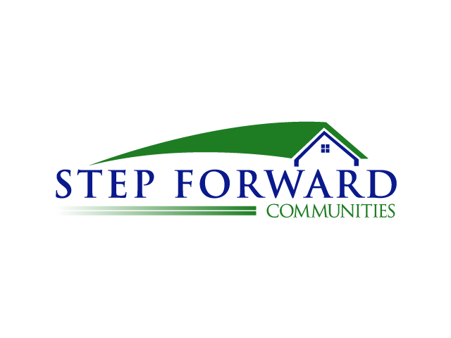

638 Camino De Los Mares
Suite H130-467
San Clemente, CA 92673
949-216-0210

Volunteer Standards of Conduct
By accepting to volunteer with us, you have a responsibility to the tenants, staff and other volunteers at the property to adhere to certain guidelines for conduct. Generally speaking, we expect every volunteer to act in a mature and responsible way at all times. When each person is aware that he or she can fully depend upon fellow volunteers to follow these Standards of Conduct, then our organization will be a better place to volunteer for everyone.
- Always ensure the safety of all participants and volunteers
- Treat everyone fairly, regardless of gender, ethnic background, religion, political belief or economic status
- Conduct yourself in a manner that demonstrates a positive role model and a responsible representative to the community
- Consistently display high personal standards and project a favorable image including personal hygiene and appearance.
- Wear modest clothing that is neat, clean and void of rips with no offensive language.
- Respect the dignity of the participants, staff and other volunteers
- Refrain from public criticism of participants, staff or other volunteers
- Refrain from the use of profane, insulting, harassing or otherwise offensive language while volunteering
- Abstain from and discourage the use of drugs, alcohol and tobacco products on the property
- Report, to the property manager, any incident that might be contrary to this Volunteer Standard of Conduct
If you have any questions concerning any volunteer conduct or safety rule, or any unacceptable activity at this property, please contact Step Forward Communities or the property manager.

You must sign on the volunteer Application that you have read and will comply by these standards.

Thank you

