Step Forward Communities
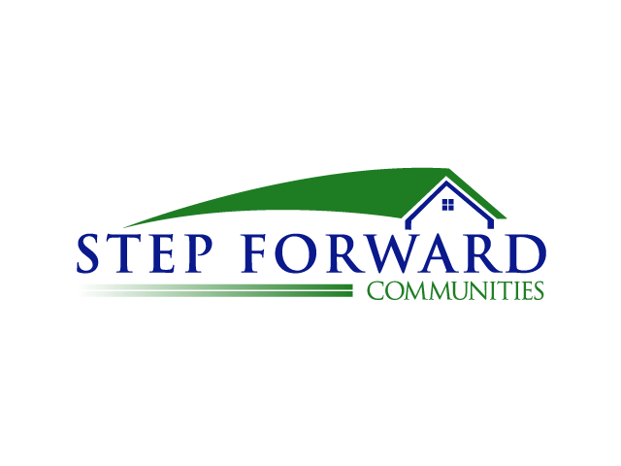
Volunteer Application
Today's Date: ____________

Name: _______________________________________________________

Street Address: ________________________________________________

City, Zip Code: _________________________________________________

Home Phone: _____________________________ Cell Phone: _________________________________

Home E-mail: _____________________________ Work E-mail: ________________________________

Gender: __________________________________ DOB (MM/DD/YYYY): __________________________

EMERGENCY CONTACT INFORMATION

Emergency Contact: ______________________ Relationship: _________________

Home phone: ___________________________ Cell phone: _________________________________

Have you ever been arrested or convicted of a crime? Yes or No, if yes please give details. YES NO

_______________________________________________________________________________________

_______________________________________________________________________________________Do you have any physical limitations that would impair your ability to perform as a volunteer without supplemental assistance?
_________________________________________________________

Employer/School Name? ___________________________________________________________________

In what area are you interested in volunteering? _______________________________________________

Do you have any other relevant volunteer experience?
Name of Volunteer Organization and duties performed. __________________________________________

Do you have any education or training experience in this area of service? ____________________________

APPLICATION VERIFICATION
I hereby affirm that the information provided on this application is true and complete to the best of my knowledge and agree to have any of the statements checked by the organization. I understand that providing any false or misleading information or any omissions may disqualify me from further consideration as a volunteer and may result in my immediate termination, even if discovered at a later date.
I authorize representatives of Step Forward Communities to conduct a thorough investigation of all my activities, and authorize all references provided in this application to provide all information they have about me.
I have read and will comply with Step Forward Communities Volunteer Standards of Conduct. I understand that not following these policies will lead to my removal from the property

______________________________________________________ _______________________
Signature Date

